LLAMA LLAMA RED PAJAMA

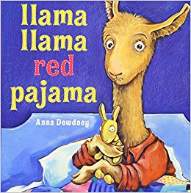

Llama Llama red pajama

Reads a story with his mama.

Mama kisses Baby’s hair.

Mama Llama goes downstairs.

Llama Llama red pajama

Feels alone without his mama.

Baby Llama wants a drink.

Mama’s at the kitchen sink.

Llama Llama red pajama

Calls down to his llama mama.

Mama says she’ll be up soon.

Baby Llama hums a tune.

Llama Llama red pajama

Waiting waiting for his mama.

Mama isn’t coming yet.

Baby Llama starts to fret.

Llama Llama red pajama

Wimpers softly for his mama.

Mama Llama hears the phone.

Baby Llama starts to moan…

Llama Llama red pajama

Listens, quiet, for his mama.

What is Mama Llama doing?

Baby Llama starts boo hoo-ing.

Llama Llama red pajama

Hollers loudly for his mama.

Baby llama stomps and pouts.

Baby Llama jumps and shouts.

Llama Llama red pajama

In the dark without his mama.

Eyes wide open, covers drawn

What if Mama Llama’s GONE?

Llama Llama red pajama

Weeping, wailing for his mama.

Will his mama ever come?

Mama Llama, RUN RUN RUN!

Baby Llama, what a tizzy!

Sometimes Mama’s very busy.

Please stop all this llama drama

And be patient for your mama.

Llama Llama, don’t you know,

Mama Llama loves you so?

Mama Llama’s always near,

Even if she’s not right here.

Llama Llama red pajama

Gets two kisses from his mama.

Snuggles pillow soft and deep…

Baby Llama goes to sleep.

LLAMA LLAMA MAD AT MAMA

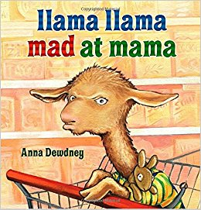

Llama Llama having fun

Blocks and puzzles in the sun.

Time to shop! It’s Saturday!

Llama Llama wants to play.

First the shopping, then a treat.

Mama Llama gets the seat.

Llama dreaming in the car-

Wake up! Wake up! Here we are!

Great big building, great big signs.

Lots of aisles, lots of lines.

Llama Llama out with Mama

Shopping at the Shop-O-Rama.

Yucky music, great big feet.

Ladies smelling way too sweet.

Look at knees and stand in line.

Llama Llama starts to whine.

Clearance sales and discount buys.

What is little llama’s size?

Try it on and take it off.

Pull and wiggle, itch and cough.

Shirts and jackets, pants and shoes.

Does this sweater come in blue?

Brand new socks and underwear?

Llama Llama does not care.

Cheezee Puffs and Oatie Crunch

What would llama like for lunch?

Llama Llama doesn’t know.

Llama Llama wants to go.

Loaf of bread and Cream of Wheat.

Llama Llama wants his treat.

It’s no fun at Shop-O-Rama.

Llama Llama MAD at Mama!

Flying pasta, spraying juice,

Paper towels rolling loose.

Coffee, bread, and chips galore.

Shoes and sweaters hit the floor.

CRASH the cart and SMASH the signs.

NO more waiting! No more lines!

Out go socks and Cheezee Puffs…

Llama Llama, that’s enough!

Please stop fussing, little llama.

No more of this llama drama.

I think shopping’s boring too-

But at least I’m here with you.

Let’s see if we can make this fun

And get the llama shopping done.

Let’s be a team at Shop-O-Rama-

Llama Llama shops WITH Mama!

Sweep up pasta, mop up juice.

Wrap up towels rolling loose.

Pick up puffs and find the socks.

Put the shoes back in the box.

Push the cart with Mama Llama,

Almost done at Shop-O-Rama.

Snap the buckle, grab the box,

Put on brand-new shoes and socks.

Say good-bye to Shop-O-Rama.

Llama Llama LOVES his mama.

LLAMA LLAMA HOLIDAY DRAMA

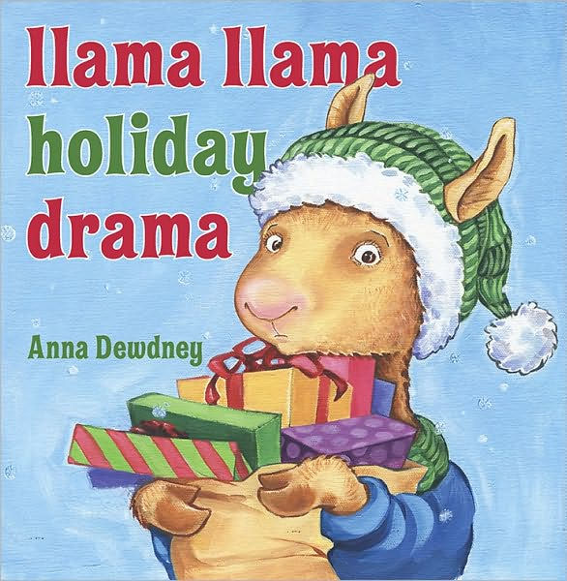

Llama Llama holidays.

Jingle music. Lights ablaze.

Sparkly candles. Yummy bread.

Dress-up clothes in green and red.

How long till that special date?

Llama Llama has to wait.

Llama Llama holidays.

Ads and signs and store displays.

Fluffy snow and funny elves.

Goodies piled high on shelves.

Just how many days to go?

Llama Llama wants to know.

Time to buy and search and shop.

Mama carries. Mama drops.

Buy a friend a rubber duck?

Pirate ship or tractor truck?

Wooden blocks or building set?

What will Llama Llama get?

Llama Llama holidays.

Hustle bustle. Cooking craze.

Measure sugar. Roll the dough.

Ten more batches left to go…

How many more days, again?

The special day is coming when?

Take the cookies out to cool.

Frost a great big batch for school!

Add some sprinkles. Almost done…

Teacher gets the fancy one.

No more cookies left to bake!

Llama Llama tummy-ache.

School has dreidels, songs, and bells.

Big red ribbons, woodsy smells.

Draw a snowman. Make a star.

Decorate a candle jar.

Are there many days to go?

Llama time is going SLOW…

Llama Llama holidays.

Unpack stockings. Unwrap trays.

Shiny silver. Fancy plates.

Llama Llama waits, waits, waits.

Cut out snowflakes. Tape them up.

Pour some eggnog in a cup.

Oops! It’s yucky on the floor.

Llama Llama waits some more.

Stringing lights is not much fun.

How come Mama isn’t done?

Is the big day coming soon?

Llama Llama starts to swoon…

All this waiting for one day?

Time for presents RIGHT AWAY!

Too much music, too much fluff!

Too much making, too much stuff!

Too much everything for Llama…

Llama Llama, HOLI-DRAMA!

Come and listen, little Llama.

Have a cuddle with your mama.

Sometimes we should take a rest

And hold the ones we love the best.

Wishing, waiting, wanting things…

We forget what this time brings.

Gifts are nice, but there’s another-

The true gift is we have each other.

Llama Llama, warm and snug,

Gives a kiss and gets a hug.

Snuggles close with Mama Llama…

Happy Holidays for Llama.

LLAMA LLAMA MISSES MAMA

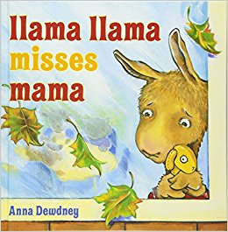

Llama Llama, warm in bed.

Wakey, wakey, sleepyhead!

Llama school begins today!

Time to learn and time to play!

Make the bed and find some clothes.

Brush the teeth and blow the nose.

Eat some breakfast. Clean the plate.

Woops! Oh my- we’re running late!

Drive to school and park the car.

Tell the teacher who you are.

Meet new faces. Hear new names.

See new places. Watch new games.

Hang the coat and say good-bye.

Llama Llama feeling shy…

Mama Llama goes away.

Llama Llama has to stay.

Strange new teacher. Strange new toys.

Lots of kids and lots of noise!

What would Llama like to do?

Llama Llama feels so new…

Build a castle out of blocks?

Make a rocket from a box?

Llama Llama shakes his head.

Llama walks away instead.

Here’s a little chugga-choo

With a captain and a crew.

Would the Llama like a ride?

Llama Llama tries to hide.

Reading stories on the rug,

Kids are cuddled, sitting snug.

Would the Llama like to look?

Llama Llama hates that book.

Time for lunch! Now find a seat.

Llama doesn’t want to eat.

Llama makes a little moan.

Llama Llama feels alone.

Llama misses Mama so…

Why did Mama Llama go?

It’s too much for little Llama…

Llama Llama MISSES MAMA!

Don’t be sad, new little Llama!

It’s OK to miss your mama.

But don’t forget- when day is through,

She will come right back to you.

Llama Llama, please don’t fuss.

Have some fun and play with us!

Put on coats and run outside.

See the playhouse! Try the slide.

Tag and jump rope. Hide and seek.

Close your eyes and do not peek!

Now it’s time to draw and write.

Great big crayons. Colors bright.

Take some paper from the stack…

Mama Llama, you came back!!!

Lots to show and lots to say!

Back again another day.

Llama finds out something new-

He loves Mama… and SCHOOL, too!

LLAMA LLAMA HOME WITH MAMA

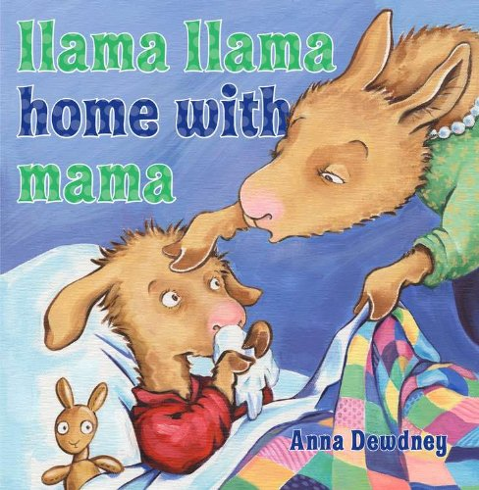

Llama Llama, morning light.

Feeling yucky, just not right.

Down to breakfast. Tiny sneeze.

Sniffle, snuffle. Tissues, please!

Llama’s head is feeling hot.

Llama’s throat is hurting lots.

Achy, fever, stuffy head…

Llama Llama, back to bed.

Time to rest. No school today.

Mama Llama brings a tray.

Fruity medicine tastes yucky!

Llama Llama’s throat feels gucky.

Look around. Not much to do.

Trucks are boring. Tractors, too.

Make a tunnel for a train?

Llama Llama, fuzzy brain.

Mama Llama gets a book,

Have a listen. Take a look.

Heavy eyelids. Drippy nose.

Llama Llama starts to doze.

Up again and feeling better.

Draw some pictures. Make some letters.

Llama wants a sandwich, please!

Mama Llama starts to sneeze.

Lunch is over. Time for toys!

Mama’s head does not like noise.

Mama makes a big ah-choo!

Llama’s out of things to do.

Uh oh! Mama’s throat is sore.

Being sick is such a bore.

Mama coughs, and Llama yawns…

How long can this day go on?

Mama shnortles, hacks and wheezes.

Llama Llama’s sick of sneezes!

Soggy tissues, gobs of yuck.

Sniffing, snorting, sneezing, YUCK!

Llama Llama, red pajama,

Sick and bored, at home with Mama.

Wait! Llama Llama knows what’s best.

Mama Llama needs a rest!

Get more tissues. Bring a cup.

Fluff a comfy pillow up.

What else could Mama Llama need?

How about some books to read?

Just the thing for Llama Llama,

Sick at home… but with his mama.

LLAMA LLAMA TIME TO SHARE

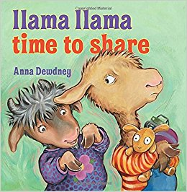

Llama Llama, playing trains,

Driving trucks, and flying planes.

Someone’s at the door… who is it?

Brand new neighbors come to visit.

Llama, this is Nelly Gnu.

Look! She has a dolly too.

Mrs. Gnu, would you like tea?

Come and have a cup with me.

You two kids can play in there…

And Llama, don’t forget to share.

Trains and trucks and puzzles, too.

What’s the Gnu girl want to do?

Play with kitchen? Build with blocks?

Llama opens up his box.

Nelly starts to build a town.

Llama Llama starts to frown…

Nelly Gnu makes walls and stairs.

Llama watches from a chair.

Nelly stacks the blocks up high.

Fuzzy Llama wants to try.

It’s a castle! Make it tall.

Fuzzy Llama jumps the wall!

Build a tower. Make a moat.

Nelly’s dolly rows a boat.

What can Llama Llama add?

Maybe sharing’s not so bad.

Little baby Gnu makes noise.

Mrs. Gnu gets jingly toys.

Baby screams and kicks his feet.

Mama thinks it’s time to eat.

Moms are talking, baby’s chewing…

Where’s that Gnu girl? What’s she doing?

Oh, disaster! Dolly drama!

Nelly Gnu has Fuzzy Llama!

He’s not hers! This isn’t fair!

Llama DOESN’T LIKE to share!

Fuzzy Llama ripped in two…

All because of Nelly Gnu!

It’s a llama-mergency!

Mama! Fix his arm for me!

A bit of thread and good as new…

But this is what we’re going to do:

I’ll put Fuzzy on the stairs

Until you’re SURE that you can share.

Nelly’s sorry. Llama too.

It’s time for something else to do.

Look- our fancy cake is done!

Hmmm… what would make this game more fun?

Fuzzy Llama, on the stairs!

Llama thinks it’s time to share.

Playtime’s over. It’s the end…

But Llama has a brand new friend.

Nelly will be back, and then…

Llama wants to share again!

LLAMA LLAMA GRAM AND GRANDPA

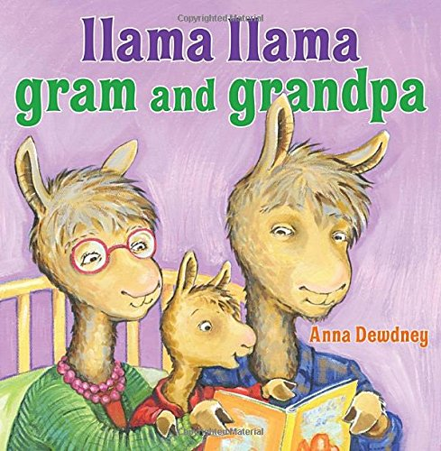

Llama Llama, big big day!

It’s a first- a special stay.

Pack up clothes and pj’s tight-

Llama’s going overnight.

Who will take good care of Llama?

Llama Llama’s Gram and Grandpa!

Bag and Fuzzy? In the car!

Buckle up! The drive seems far…

Hugs and kisses. Big hellos.

Mama loves you! Off she goes.

A glass of milk. A yummy snack.

Now it’s time to go unpack.

Mama’s picture in a frame.

Different. Also just the same.

Take out socks and pants and book.

Put the jammies on the hook.

Feeling strange away from Mama.

Oh no… WHERE IS FUZZY LLAMA?

Llama dear, are you OK?

Llama doesn’t want to say.

Grandma says, let’s go outside.

Climb on up. Pretend to ride.

Tractor, gardens, grass to mow-

Llama’s having fun. But… oh…

Fuzzy is still left at home.

Maybe Fuzzy feels alone?

Grandpa’s workshop- lots to do.

Wood and hammers. Nails and glue.

Llama makes a little chair.

It’s for Fuzzy… who’s not there.

Time for dinner. Help get ready.

Carry dishes. Hold them steady.

Grandma’s house has different food.

Something squishy. Something stewed.

Llama tries it, and it’s good.

Would you like more? Llama would!

Dinner’s over. Time for bed.

Llama wants to wait, instead.

Grandpa says, let’s see the stars.

Nighttime shows us where they are.

Take a bath. Then comb and brush.

Settle in for stories. Hush.

Finish books and get a kiss.

Llama dear, now what IS this?

Llama’s lips begin to quiver.

Llama starts to shake and shiver.

Llama needs his Fuzzy near,

But FUZZY LLAMA ISN’T HERE!

Wait a minute. Stay right here.

Grandpa leaves, then reappears.

When Grandpa was a little boy,

He also had a special toy.

Big or little, young or old,

A llama needs someone to hold.

A Grandma kiss. A Grandpa hug.

Feeling cozy. Settled snug.

Llama Llama’s not alone.

This is home… away from home.

LLAMA LLAMA AND THE BULLY GOAT

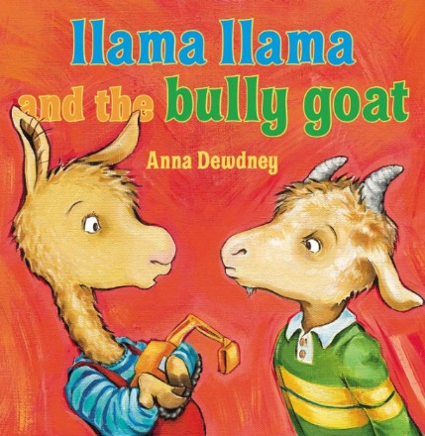

Llama Llama, busy day,

Writing, counting, pictures, clay.

Roll a pancake. Draw the sun.

Almost everyone has fun.

Time for circle. Time for song.

Time to clap and sing along.

Kitty, Rhino, Sheep and Calf,

Llama, Nelly, and Giraffe

All sing songs in their own way:

Moo and bellow, baa and bray.

Llama Llama claps the beat.

Gilroy Goat just points and bleats.

Sheep goes baa and Calf goes moo.

Gilroy thinks that’s silly, too.

Llama Llama likes to sing.

Gilroy laughs at everything.

Llama sings out just the same.

Gilroy says a not-nice name.

Teacher has some things to say.

Calling names is not OK.

Being mean is not allowed.

Teacher says to stop it now.

Time for recess! Go outside!

Monkey bars and slippy-slides.

Nelly’s dolly makes a road.

Fuzzy Llama pulls a load.

Kids climb up and kids climb down.

Everybody runs around.

Nelly’s dolly wants to dig.

Fuzzy drives a great big rig.

Gilroy stands in Fuzzy’s way.

Gilroy, do you want to play?

Gilroy bleats and kicks the dirt.

He gets sand on Llama’s shirt.

Gilroy throws some dirt at Nelly.

Ha ha! Gnus are really smelly!

Gilroy pushes- Fuzzy falls!

Ha ha! Llamas play with dolls!

Gilroy snickers, laughs and kicks,

Gilroy tosses toys and sticks.

Gilroy stomps on Llama’s coat.

Gilroy is a… BULLY GOAT!

Gilroy, this is NOT OK.

Stop it, or we’ll go away.

Being bullied is no fun!

Walk away… and tell someone!

Gilroy fusses, frowns, and pouts.

Gilroy gets a long time-out.

Teacher says, let’s try again.

Gilroy, can you be a friend?

No more kicking. No more names.

Time to play a nicer game.

End of recess! Back inside.

Gilroy sits by Teacher’s side.

Everybody sings the song,

And this time, Gilroy sings along.

Gilroy Goat has fun with Llama,

But school is over- here comes Mama.

Tomorrow has more games to try…

See you then! Friends wave good-bye.